**Intuitions about Joint Action Study**

**Experiment 1**

**Procedure**

3 Conditions:

* Baseline: they form a shared intention and both are sticking to it
* N+O: The ‘Gilbert Condition’, i.e. , both have privately decided to abandon the plan
* Parallel: Each has formed the intention privately; Olive has privately decided to drop it but we do not know about Ned

3 Test Questions/ 3DVs:

* Shared Intention (Would you agree with Olive’s statement?)
* Commitment
* Obligation

**Bar Graphs**

**Regressions**

*Commitment as a Predictor of Shared Intention:*

Multiple R-squared: 0.3333, Adjusted R-squared: 0.3263

F-statistic: 47.49 on 1 and 95 DF, p-value: 6.011e-10

*Obligation as a predictor of Shared Intention:*

Multiple R-squared: 0.01113, Adjusted R-squared: 0.0007218

F-statistic: 1.069 on 1 and 95 DF, p-value: 0.3037

*Obligation as a predictor of commitment:*

Multiple R-squared: 0.05123, Adjusted R-squared: 0.04125

F-statistic: 5.13 on 1 and 95 DF, p-value: 0.02579

**Experiment 2**

**Procedure**

3 Conditions: Same as Exp 1 but the language is different – i.e. instead of saying ‘Our intention is to X’, Olive says ‘We will X’

DVs as in Exp 1

**Bar Graphs**

**Regressions**

*Obligation as predictor of SI*

Multiple R-squared: 0.09612, Adjusted R-squared: 0.08608

F-statistic: 9.571 on 1 and 90 DF, p-value: 0.002634

*Obligation as predictor of Commitment*

Multiple R-squared: 0.1659, Adjusted R-squared: 0.1567

F-statistic: 17.9 on 1 and 90 DF, p-value: 5.582e-05

*Commitment as predictor of SI*

Multiple R-squared: 0.1987, Adjusted R-squared: 0.1898

F-statistic: 22.32 on 1 and 90 DF, p-value: 8.475e-06

**Experiment 3**

**Procedure**

2 Conditions:

* Post: They have begun walking up the hill (Same as ‘Gilbert Condition’)
* Pre: They have formed the plan, and each has privately decided to abandon it the day before, and the key statement is made the day before

DVs as in Exp 1

**Results**

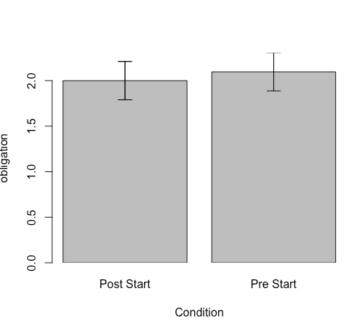

**FURTHER EXPERIMENTS**

**Experiment 2b**

BL: Roz and Dan have decided to play a tennis match on Tuesday morning. During the second set, their friend Phil arrives and approaches the court to greet them. Roz tells him, ‘We are playing a match.’

N+O:

Roz and Dan have decided to play a tennis match on Tuesday morning. Midway through the second set, Roz decides that she has had enough tennis and is going to stop after the second set. As it happens, Dan has the very same thought, but neither of them says anything just yet. During the second set, their friend Phil arrives and approaches the court to greet them. Roz tells him, ‘We are playing a match.’

Parallel:

Roz and Dan are both individually practicing tennis on courts next to each other on Tuesday morning. Roz had planned on practicing for an hour, but after about 20 minutes she decides that she has had enough tennis and is going to stop in a moment. Just then, their friend Phil arrives and approaches the court to greet them. Roz tells him, ‘We are practicing for an hour.’

**Experiment 3b**

Post-Start (Gilbert Condition): Roz and Dan have decided to play a tennis match on Tuesday morning. Midway through the second set, Roz decides that she has had enough tennis and is going to stop after the second set. As it happens, Dan has the very same thought, but neither of them says anything just yet. During the second set, their friend Phil arrives and approaches the court to greet them. Roz tells him, ‘We are playing a match.’

Pre-Start: Roz and Dan have decided to play a tennis match on Tuesday morning. The day before, Roz decides that a match is too long, and that she will stop after the second set. As it happens, Dan has the very same thought, but neither of them says anything just yet. Just then, their friend Phil appears and Roz tells him, ‘We are playing a match tomorrow.’